1. 
2. 
3. All the statements should run successfully or the transaction should fail.
4. 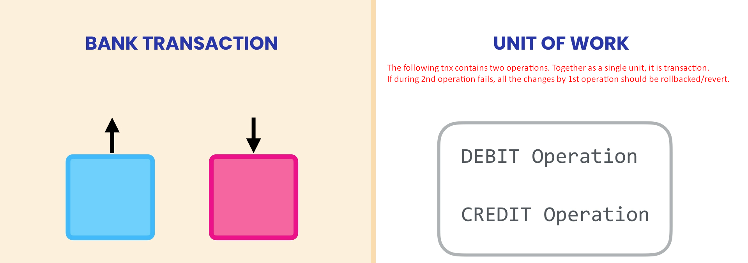
5. 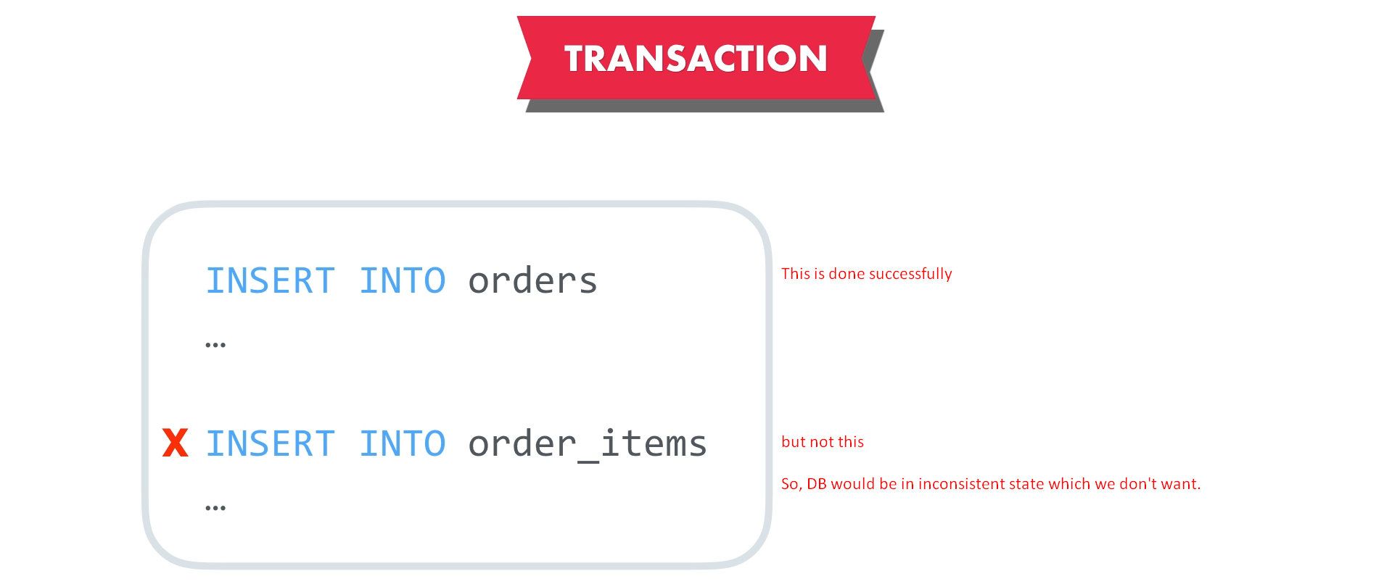
6. A Transaction has a few properties

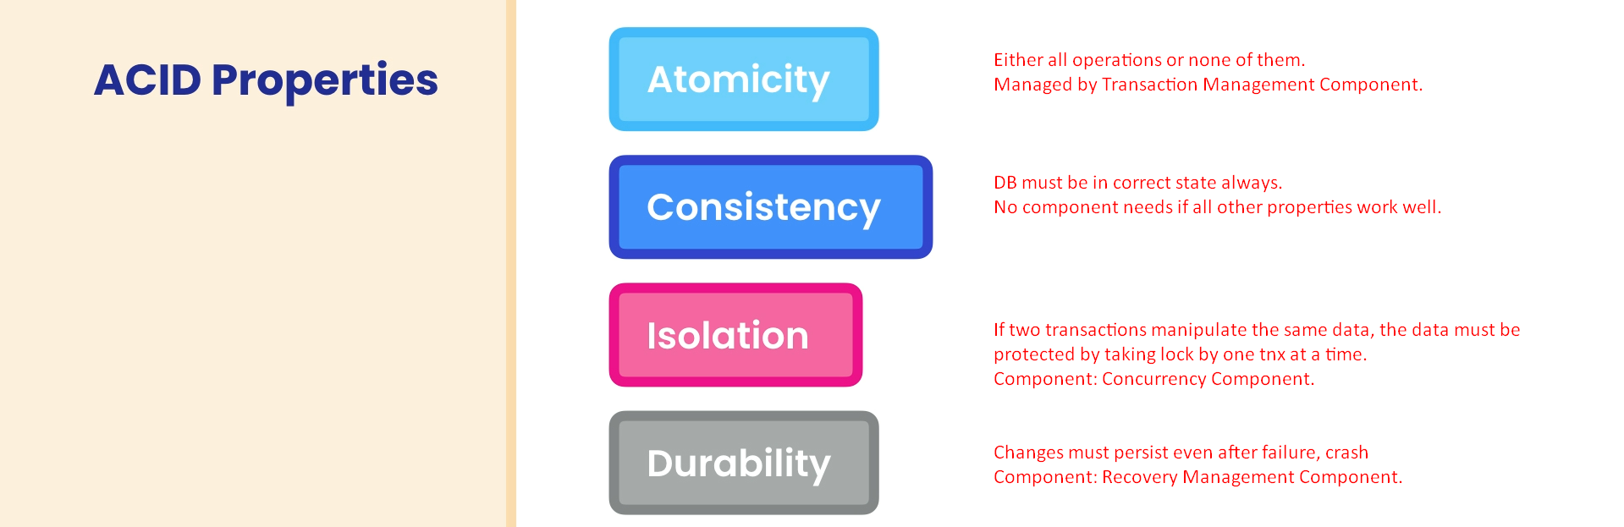

1. **ACID managed by DB Components**
   1. **Atomicity**: managed by Transaction Management Component.
   2. **Consistency**: If all properties of Tnx works fine, it automatically works fine.
   3. **Isolation**: Concurrency Management Component.
   4. **Durability**: Recovery Management Component.